HOW TO USE GREEN SCREEN IN CAMLYNX

Green Screen (or Blue Screen) Photography is becoming more popular. It started as a way to place actors in front of a different location in film photography and video. Green screen photography is used more often with Sports, Events and Studio work, but many school photographers are looking for an easy way to replace backgrounds in the images the capture. This gives their subjects more choices for their packages. The photographer can also replace green screen to get a consistent background on all images for Composites and Yearbooks. Then they can offer the same image with seasonal backgrounds throughout the year to sell additional reorder packages.
Common Green Screen Shooting tips:
- Use a Saturated Green or Blue background – using Green is more commonly used with still photography but either will work. Sometimes the background color reflects on the subject causing a green or blue spill. Because blue spill doesn’t look as bad as green spill, some photographers prefer using a Blue background.
- It is important to have the background screen lit evenly. Natural Sunlight works well for even lighting, as long as you find a shadow free area and can shoot outdoors.
- Position the subject far enough away from the background that they don’t produce shadows on the background. Six –12 feet is the recommendation that I got from my sources.
- Using a straw colored or yellow backlight on the subject helps to reduce the “matte line” around the subject.
- Placing the subject far enough away from the backdrop also allows the photographer to use separate, more dramatic lighting on the subject.

The Green Screen settings in CamLynx aren’t as scary as they sound. Using Green Screen for Volume Productions is still in development, however, the existing function is works well for small projects.

Right-Click on an image in the CamLynx Image Queue. The Image Adjustments window will open.

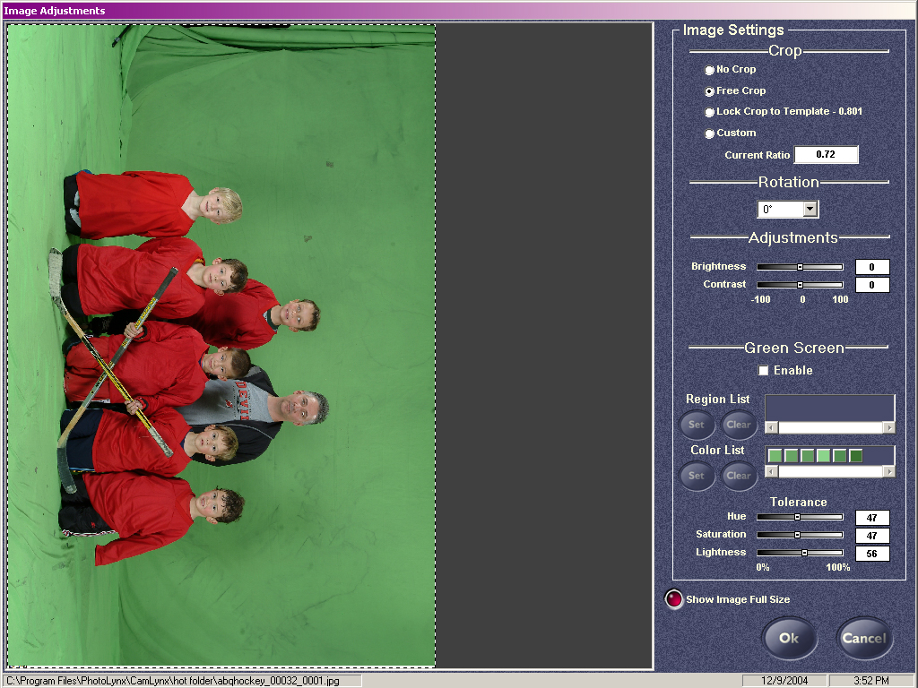

Click the Enable checkbox in the green screen area to turn on the green screen functions.
Click Set in The Color list and choose some samples of the background from several places on the background. Use the 3 tolerance settings to remove all of the background from the picture.
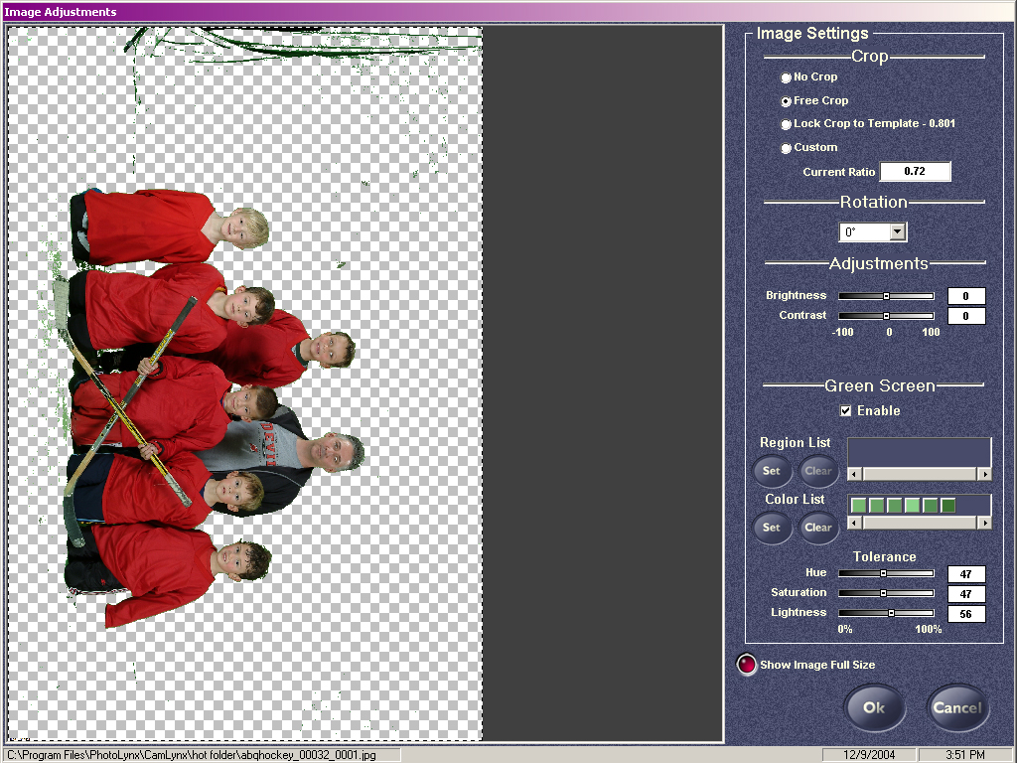

Click OK when you have removed as much of the background as possible.
With Green Screen enabled, the Image Adjustment Screen will come up for each picture on save so that the photographer can adjust the color selections and tolerances for each image (in case of lighting and position variations).

When CamLynx removes the background, it replaces it with Magenta (255-0-255 on the RGB scale). This is so that the image can be quickly dropped into a template built by CamLynx or ProServices using the current Transparency controls.

Clients are looking for a way to remove the Background and replace it with a selected background immediately, without building a template. They would want the saved image to be ready for package printing and services. They would also want the image to be saved in a way that would allow them to replace the background again at a later time for reorders.

